Advanced Prompt Engineering Architecture for Gemini 3.1 Flash Image (Nano Banana 2)

Introduction to the Next-Generation Multimodal Architecture
The paradigm of generative artificial intelligence has shifted dramatically from the stochastic interpretation of disjointed keywords to the deterministic execution of complex semantic directives. With the deployment of Gemini 3.1 Flash Image—officially recognized within the developer and creative communities as Nano Banana 2—Google DeepMind has fundamentally redefined the parameters of prompt engineering. Launched on February 26, 2026, this model represents a critical inflection point in the industry, merging the advanced reasoning and deep spatial comprehension previously exclusive to "Pro-tier" models with the low latency and cost-efficiency characteristic of the "Flash" architecture.¹
Historically, prompt engineering for diffusion models relied heavily on "keyword soup"—the practice of stringing together dozens of loosely related tags in hopes of guiding the latent space toward a desired outcome. Nano Banana 2 renders this methodology obsolete. Built upon the multimodal foundation of the Gemini 3 series, it possesses an extraordinary context window of 128,000 input tokens and 32,000 output tokens, allowing it to process massive textual documents, up to 14 high-resolution reference images, and complex JSON schemas simultaneously.³ Furthermore, its integration of Advanced World Knowledge via real-time Google Search grounding ensures that visual outputs are anchored in factual reality rather than algorithmic approximations.¹
This comprehensive research report systematically deconstructs the optimal strategies, syntactical frameworks, and advanced methodologies required to extract professional-grade visual assets from Gemini 3.1 Flash Image. By analyzing core prompt anatomy, multimodal interaction techniques, granular photographic controls, and sophisticated edge-case mitigations, this document serves as the definitive architectural guide for interacting with the Nano Banana 2 latent space.

1. Core Prompt Anatomy & Syntax
To effectively maneuver the latent space of Gemini 3.1 Flash Image, practitioners must abandon legacy prompting habits and adopt the mindset of a technical creative director. The model’s neural architecture evaluates input syntactically, assessing intent, context, physical parameters, and exclusions as a cohesive, hierarchical narrative.⁵

1.1 The Definitive Structural Formula
Empirical analysis of high-yield outputs reveals that Nano Banana 2 responds most reliably to a declarative, highly structured formula. Rather than appending descriptors randomly, the prompt must build the scene logically from the subject outward to the environmental physics, and finally to the capture mechanism.⁵ The established optimal formula is defined as follows:
** + [Action/Kinetics] + [Environment/Context] + + [Lighting/Atmosphere] + [Camera/Hardware Parameters]**.⁵
The efficacy of this formula lies in its alignment with the model's sequential rendering logic. The model establishes the primary subject weights first, contextualizes them within a spatial grid, applies physical lighting algorithms, and finally filters the image through simulated optical metadata.
To demonstrate this architecture, consider the breakdown of each module:
- Subject: Precision is paramount. A vague prompt yields a generic output. Instead of requesting "a classic car," the expert prompt must specify "a meticulously restored 1969 Ford Mustang Mach 1, featuring factory-original Grabber Blue paint and pristine chrome trim."
- Action/Kinetics: This defines the kinetic energy, tension, or posture of the subject. A subject at rest requires different anatomical weighting than one in motion. A specific action might be "idling aggressively, with dense exhaust fumes faintly visible in the frigid morning air."
- Environment/Context: This establishes the spatial grounding and prevents the model from generating an ambiguous void. An effective environment description would be "parked on wet, uneven cobblestones within a narrow, dimly lit historical alleyway in Prague."
- Spatial Composition: This directs the virtual soundstage, dictating where the subject exists relative to the viewer. Directives such as "low-angle perspective, three-quarter front profile, adhering to the rule of thirds" provide strict geometric boundaries.
- Lighting/Atmosphere: The model natively understands the physics of light propagation. Directives must specify the exact light sources and their physical behavior, such as "cinematic color grading, neon-soaked cyberpunk aesthetic, harsh rim lighting cast from an unseen off-camera streetlamp."
- Camera/Hardware Parameters: This terminal layer maps to physical photographic equipment. Instructing the model to simulate "shot on 35mm film, Fujifilm Superia X-TRA 400 stock, 50mm prime lens, f/2.8 aperture" forces the model to apply specific grain algorithms, color science, and optical depth of field characteristics.

1.2 Token Weighting and Positional Attention Dynamics
A critical advancement in the Gemini 3 architecture is its handling of token weights across its expansive 128,000-token input window.³ Legacy diffusion models suffered from catastrophic forgetting, where instructions placed at the end of a long prompt were entirely ignored in favor of the initial tokens. Nano Banana 2 possesses robust long-context retention capabilities, ensuring that complex, multi-paragraph prompts are comprehended in their entirety.⁵
However, the attention mechanism is not uniform. The model exhibits distinct behavioral patterns regarding where certain types of instructions are placed. The most critical insight regarding token positioning involves the placement of constraints. Extensive testing demonstrates that when processing complex, multi-layered requests, the model may inadvertently drop negative constraints, quantitative restrictions (such as exact object counts), or rigid formatting rules if they are embedded too early in the prompt.⁸
The underlying cause of this behavior is that early tokens are utilized to establish the primary generative trajectory and conceptual foundation. If a constraint is introduced during this conceptualization phase, it may be overshadowed by the overwhelming weight of the positive generative directives that follow. Therefore, the optimal strategy dictates that the core creative request must initiate the prompt, while all rigid restrictions—specifically negative exclusions and strict formatting rules—must be securely anchored at the absolute terminal end of the text block.⁸ This terminal positioning ensures that the constraints act as a final, definitive filtering layer immediately prior to the execution of the diffusion process.

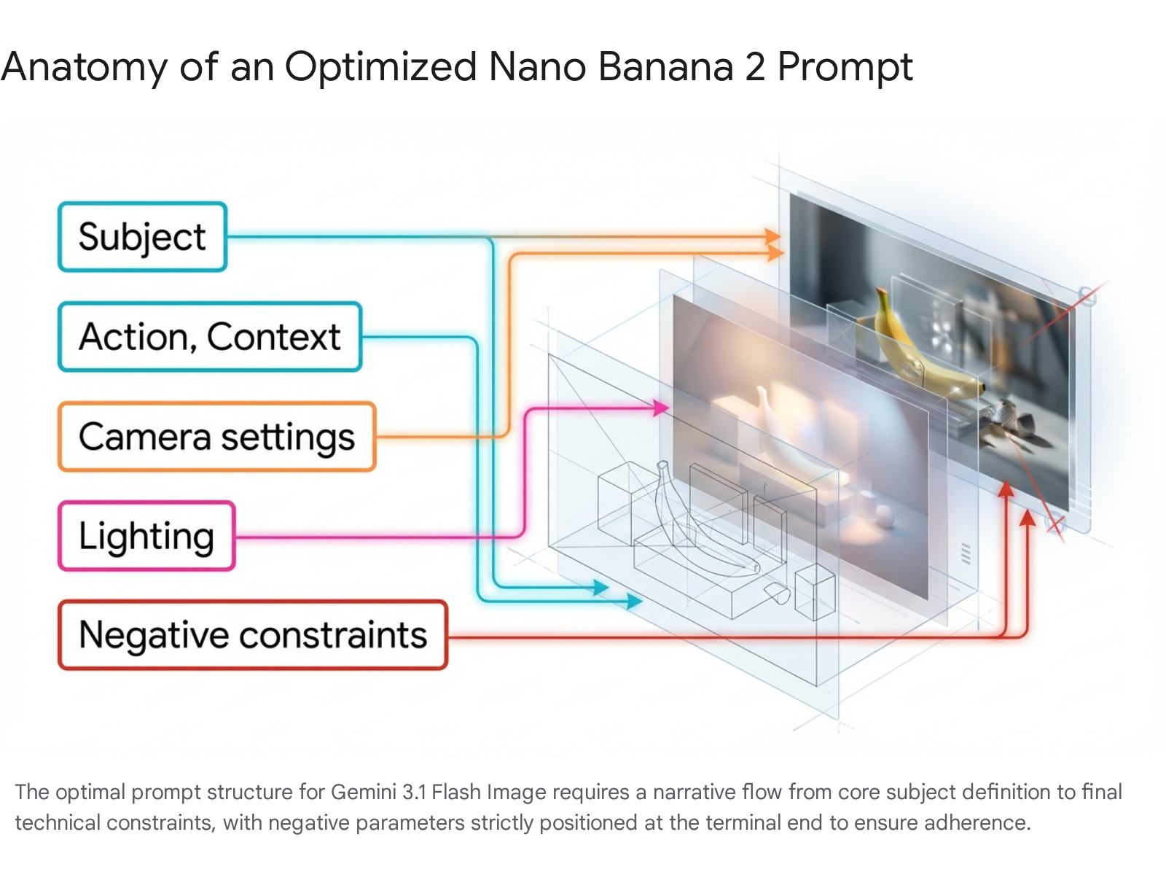

1.3 Trigger Modifiers and the Lexicon of Photorealism
While the model fundamentally rejects chaotic keyword stuffing, strategically integrating specific, industry-standard photographic, atmospheric, and artistic terminology acts as a powerful catalyst. These terms function as "magic words" that reliably trigger high-fidelity, highly resolved clusters within the model's latent space, pushing the output past standard AI generation and into the realm of professional asset creation.
To achieve unparalleled photorealism, the prompt must dictate the interaction of light with physical surfaces. The utilization of terms such as "high contrast lighting" and "deep shadows" invokes complex shadow rendering algorithms that provide volumetric depth, which is essential for moody or cinematic portraiture.⁵ For commercial viability, explicitly requesting "softbox lighting" triggers the model to simulate the diffused, even illumination characteristic of professional studio environments, neutralizing harsh highlights.⁹ Furthermore, "high dynamic range (HDR)" ensures that micro-details are preserved simultaneously within the darkest shadows and the brightest highlights, preventing information clipping.⁹
Equally critical is the simulation of camera hardware and optical physics. By specifying an "8K resolution" output, the prompt encourages the model to dedicate maximum computational resources to high-frequency detail generation.⁹ The inclusion of focal lengths, such as a "50mm lens style," forces the model to adhere to standard, natural human-eye proportions, thereby eliminating the warped perspectives common in algorithmic generations.⁹ To enhance realism further, one must embrace imperfections. Commands like "vintage film grain texture" and "soft lens flare" introduce organic noise and optical aberrations, disrupting the sterile, over-smoothed aesthetic often associated with AI imagery. Specifying "natural skin tones" and "subtle imperfections" ensures that human subjects possess accurate dermal textures rather than looking like plastic mannequins.⁹
When the objective shifts from strict realism to advanced stylization, the lexicon must pivot accordingly. Descriptors such as "cinematic noir" force the model into a monochromatic or heavily desaturated color space characterized by extreme contrast.⁹ Requesting a "muted color palette" results in a grounded, sophisticated aesthetic, actively suppressing the model's tendency toward oversaturated, artificial colors.⁹ Finally, terms like "rain-soaked pavement reflections" command the engine to calculate complex light bouncing and environmental mirroring, drastically elevating the perceived depth and complexity of the scene.⁹

1.4 Concrete Prompt Example 1: Editorial Photorealism
To synthesize these architectural principles, the following prompt demonstrates how to achieve ultra-photorealistic, editorial-quality portraiture while actively suppressing the generative smoothing artifacts common to lesser models.
Use Case: Generating a magazine-quality, high-fidelity portrait of an artisan, utilizing precise optical and atmospheric controls.
Optimized Prompt:
A striking editorial portrait of an elderly artisan with deeply weathered skin, intricate facial lines, and striking hazel eyes, looking directly into the lens with a stoic, reflective expression. The subject is standing inside a dusty, sunlit woodworking shop filled with out-of-focus tools in the background. Shot on a Fujifilm medium format camera, 85mm lens, f/1.8 aperture for an extremely shallow depth of field, ensuring macro-level sharp focus precisely on the subject's iris. The lighting is chiaroscuro, featuring warm golden hour backlighting that creates a distinct rim light on the subject's hair, while deep, cool-toned shadows dominate the right side of the face. The image must feature natural skin tones, pronounced vintage film grain, and subtle physical imperfections. Negative prompt: cartoon, illustration, low resolution, plastic skin, overly smooth textures, watermarks, deformed features, oversaturated colors, artificial lighting.

2. Multi-Modal Prompting: Image and Text Synthesis
The architecture of Gemini 3.1 Flash Image extends far beyond text-to-pixel generation. It is inherently multimodal, utilizing advanced vision encoders to ingest, analyze, and manipulate existing imagery based on precise semantic inputs. This capability transforms Nano Banana 2 from a standalone generator into an iterative, conversational creative studio capable of targeted edits, advanced style transfers, and multi-image compositing.⁴

2.1 Targeted Image Editing and Semantic Masking
In legacy workflows, editing a generated image required exporting the asset to an external program, manually painting a black-and-white alpha mask over the desired area, and re-importing it for inpainting. Nano Banana 2 eliminates this friction through "Semantic Masking." The model dynamically analyzes the input pixels and predicts how specific regions should transition to match the text prompt, relying entirely on the user's linguistic precision to define the boundaries of the edit.¹¹
To successfully execute targeted edits without degrading the original asset, prompt engineers must adhere to several strict best practices.
First, one must employ surgically specific exclusionary language to isolate the target. Phrases such as "change only the rug" or "edit only the sofa" create a semantic boundary, instructing the model to leave the surrounding pixel data untouched.¹¹
Second, the prompt must include explicit continuity constraints. Even when a target is isolated, the model may attempt to "harmonize" the scene by subtly shifting the global lighting, color grading, or camera angle. To prevent this background drift, the prompt must contain an explicit anchor, utilizing instructions such as: "Keep all furniture, wall art, lighting, and the camera angle exactly the same. Preserve all existing shadows and perspective".¹¹
Third, practitioners must adhere to the "One-Turn Rule." Generative stability degrades significantly when a user requests multiple, complex alterations simultaneously (e.g., changing the subject's shirt, the weather outside the window, and the color of the car in a single prompt). The optimal and most stable strategy is iterative: execute one or, at most, two highly targeted changes per conversational turn, establishing a new baseline image before proceeding.¹¹
Finally, for developers utilizing the Gemini API for conversational editing workflows, understanding thoughtSignatures is paramount. Nano Banana 2 relies on these encrypted representations of the model's reasoning context from previous turns to "remember" the original composition while executing subsequent edits.³ When asking the model to alter an image in a continuous thread, it analyzes the thoughtSignature of the prior generation. If these signatures are missing or not properly circulated back into the payload, the model loses its contextual grounding, resulting in a 400 error or a complete hallucination of the scene.³
Editing Objective | Weak Prompting (Prone to Global Shift) | Optimized Semantic Masking Prompt
Object Replacement | "Make the coffee cup into a glass of wine." | "Analyze the image. Change only the white coffee cup into a crystal wine glass filled with red wine. Preserve all surrounding desk clutter, lighting, and shadows perfectly."
Apparel Alteration | "Put him in a business suit." | "Change only the subject's casual t-shirt into a tailored navy business suit. Keep the subject's face, hair, posture, and the entire background completely unchanged."
Environmental Shift | "Make it nighttime." | "Alter the lighting to reflect midnight. Turn on the streetlamps. The core identity of the main character, their position, and the architecture must remain identical. Preserve the composition."

2.2 Concrete Prompt Example 2: Conversational Targeted Editing
Use Case: Altering the main subject's apparel while preserving a highly complex, intricately detailed background and maintaining the subject's exact identity and facial features.
Input Image: A previously generated or uploaded high-resolution photograph of a woman wearing a heavy red knit sweater, standing in the middle of a crowded, neon-lit street in Tokyo at dusk.
Optimized Prompt:
Analyze the provided reference image. Execute a targeted edit to change ONLY the red knit sweater into a sleek, tailored black leather trench coat. The new leather material must accurately reflect the exact pink and cyan neon lighting and the spatial perspective of the original scene. It is critical that you keep the subject's face, hair, and physical pose completely unchanged. Preserve the structural composition of the frame. Keep the entire background, the crowds of people, and the specific neon signs exactly the same. Do not alter the film grain, the existing depth of field, or the overall color grading of the unedited areas.

2.3 Style Transfer and Multi-Image Compositional Hierarchies
Nano Banana 2 possesses a revolutionary "Multi-Input" capability, allowing it to synthesize up to 14 distinct reference images simultaneously. This feature is utilized to blend disparate concepts, maintain strict brand identity across campaigns, or enforce character consistency across multiple sequential scenes.⁴
However, feeding multiple images into the model without strict guidance inevitably results in a chaotic, incoherent overlay of concepts. To blend elements successfully, the prompt must explicitly define the hierarchical relationship between the provided visual inputs. The optimal compositional formula for multi-modal synthesis is structured as:
** + +**.⁵
For example, if a user provides an architectural structural sketch alongside a photograph of a specific fabric, the model cannot deduce intent on its own. The prompt must instruct the model that Image A is the definitive spatial blueprint, while Image B serves strictly as the texture and color mapping index. By establishing this hierarchy, the model leverages its advanced reasoning capabilities to drape the properties of one image over the geometry of the other, resulting in seamless style transfer without structural degradation.

2.4 Concrete Prompt Example 3: Multi-Image Style Synthesis
Use Case: Rendering a professional, photorealistic product visualization by synthesizing a conceptual design sketch with physical material samples.
Inputs Provided:
- image_A_sketch.jpg (A rough, hand-drawn napkin sketch of a modern, geometric armchair).
- image_B_fabric.jpg (A high-resolution, macro photograph of a specific distressed emerald green velvet fabric).
Optimized Prompt:
Using the attached napkin sketch (image_A_sketch) strictly as the definitive structural blueprint and geometric foundation, and utilizing the attached fabric sample (image_B_fabric) as the exact texture, color, and material mapping, transform these inputs into a high-fidelity 3D product render of an armchair. The physical shape must strictly adhere to the lines of the sketch, while the upholstery must accurately reflect the emerald velvet's specific nap, sheen, and distress patterns. Place the finished armchair in the center of a sun-drenched, minimalist concrete living room. Utilize cinematic lighting with sharp shadows cast from an off-camera window. The final output must be photorealistic and suitable for a high-end furniture catalog. ⁵

3. Granular Control & Advanced Physics Simulation
To elevate outputs from standard generative approximations to professional, production-ready assets, prompt engineers must operate with the precision of cinematographers. Gemini 3.1 Flash Image models possess studio-quality controls, allowing users to manipulate virtual lighting physics, camera optics, and atmospheric conditions directly through text.⁵

3.1 Architecting Lighting and Atmospheric Physics
The Nano Banana 2 architecture natively understands and simulates the physical propagation of light across different materials. Consequently, prompting for "good lighting" or "beautiful lighting" is a squandered opportunity; engineers must define the specific light sources, their intensity, their color temperature, and their behavioral modifiers to achieve true granular control.⁵
For commercial and product workflows, studio setups must be explicitly demanded. Requesting a "three-point softbox setup" instructs the model to deploy a key light, fill light, and back light, resulting in the even, shadow-mitigated illumination characteristic of e-commerce photography.⁵
When the objective is dramatic narrative or cinematic impact, the prompt must invoke harsh physical contrasts. Directives such as "Chiaroscuro lighting with harsh, high contrast" force the model to emulate the dramatic, localized illumination seen in Renaissance paintings or classic film noir, leaving large portions of the canvas in deep shadow.⁵ Conversely, utilizing "Golden hour backlighting creating long shadows" triggers algorithms that simulate low-angle solar illumination, producing the emotive warmth and atmospheric scattering typical of dusk or dawn photography.⁵
Furthermore, engineers can dictate environmental and volumetric physics. Specifying "volumetric lighting penetrating through dense fog" forces the engine to render visible light shafts scattering off airborne particles. Commanding "neon rim lighting from an off-camera cyan sign" builds profound spatial depth, suggesting a complex world existing just outside the borders of the rendered frame.

3.2 Camera Optics and Compositional Geometry
Nano Banana 2 seamlessly interprets optical metadata. By specifying the hardware—down to the exact millimeter of the lens—developers can fundamentally alter the visual DNA, perspective, and spatial distortion of the generated image.⁵ Understanding how the model interprets focal lengths is critical for precise compositional control.

Focal Length Range | Optical Simulation in Nano Banana 2 | Primary Professional Use Cases
10mm - 24mm (Ultra-Wide) | Triggers expansive fields of view, pushing the background away while slightly distorting elements near the edges. Enhances the perception of vast scale. | Astronomical photography, sweeping landscapes, dynamic extreme sports, and immersive, tight interior architectural shots.¹⁴
24mm - 35mm (Wide) | Captures environmental context without extreme distortion. Keeps both subject and background relatively engaged in the narrative. | Photojournalism, street photography, and contextual environmental portraits.¹⁴
50mm (Standard) | Enforces natural, human-eye geometric proportions. Eliminates spatial distortion, presenting the subject exactly as it would appear to a bystander. | Standard lifestyle shots, fashion lookbooks, and objective documentation.⁹
85mm - 105mm (Telephoto/Portrait) | Isolates the subject, compressing the background (pulling it closer) while ensuring flawlessly correct facial proportions. Inherently produces a shallower depth of field. | High-end portraiture, professional headshots, beauty campaigns, and detailed macro object photography.¹⁴
Beyond focal lengths, specific lens effects can be commanded to dictate visual focus. Utilizing a "macro lens" directive ensures extreme close-up fidelity on microscopic textures. Requesting a "shallow depth of field (f/1.8)" instructs the model to calculate a narrow focal plane, keeping the subject razor-sharp while rendering the background into a smooth, optical blur (bokeh), isolating the subject from distracting elements.¹³ Conversely, demanding "deep focus (f/16)" ensures that the model renders everything from the immediate foreground to the distant background with uncompromising sharpness.

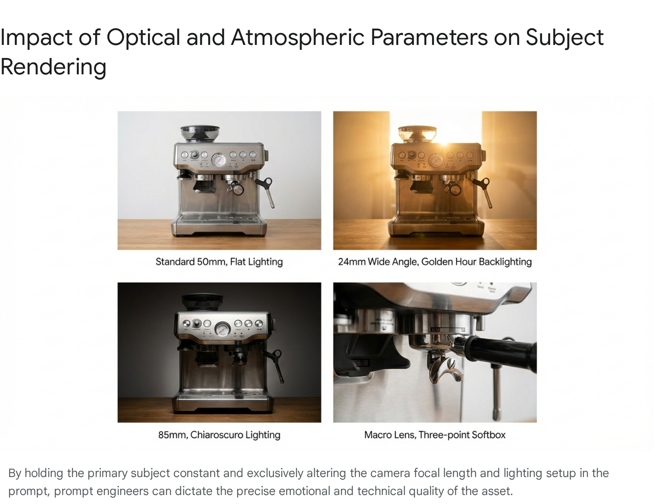

3.3 The Physics of Negative Prompting and Subtractive Weighting
Negative prompting is a cornerstone of refining generative outputs, but its application in Gemini 3.1 Flash Image requires precise syntax to avoid catastrophic failure. The model heavily utilizes negative prompts to eliminate artifacts, but practitioners must understand the underlying mechanics of how these exclusions are processed.
The most common error is utilizing conversational negatives within the main descriptive block (e.g., stating "a room with no windows" or "do not show any people"). Due to the nature of natural language processing in vision models, these conversational negatives actively confuse the cross-attention layers. The model still tokenizes and "reads" the words "windows" and "people," assigning them weight, which frequently results in the inadvertent rendering of the very objects the user sought to exclude.¹⁴
Instead, exclusions must be isolated using a dedicated negative parameter array within the API, or, if using a standard text interface, organized within a strict terminal block starting with the explicit phrase "Negative prompt:". For example, a correctly formatted exclusion would appear at the end of the prompt as: Negative prompt: greenery, plants, forest, trees, watermarks, superimposed text, blurry faces, distorted hands, unrealistic anatomical proportions.¹⁴
Furthermore, engineers must grasp the physics of subtractive weighting caused by "concept bleeding" in diffusion architectures. When a negative prompt is applied, the model does not simply erase pixels; it subtracts the mathematical weights associated with those concepts from the latent space generation.¹⁷ If a user aggressively subtracts a foundational element or a broad artistic style, they inadvertently strip away essential structural weights tied to that style, such as basic human anatomy, cohesive lighting algorithms, or perspective rendering.¹⁷ Therefore, negative prompts should be highly targeted and surgical—focused on eliminating specific artifacts (e.g., "extra fingers," "compression noise," "chromatic aberration") rather than attempting to subtract broad, foundational structural concepts.

3.4 System Parameters: Thinking Levels and Resolution Management
When accessing Nano Banana 2 via the Gemini API or Vertex AI, engineers are provided with system-level parameters that dictate the model's operational behavior before the text prompt is even parsed.
The thinking_level parameter controls the maximum depth of the model's internal reasoning and spatial planning before it produces the visual response.³ This dynamic reasoning layer allows the model to map out complex spatial relationships. The supported levels are typically minimal, low, medium, and high.³ Setting the parameter to high ensures maximum prompt adherence for complex scenes, but increases latency. Conversely, setting it to minimal is utilized to drastically minimize latency for high-throughput, bulk-generation applications, though it does not guarantee that the reasoning layer is entirely bypassed.³
Similarly, the media_resolution parameter introduces granular control over how the vision model processes input imagery, determining the maximum token allowance allocated per image. Understanding these thresholds is vital for cost and quality management:
- media_resolution_low: Allocates 280 tokens. Suitable for rapid, low-cost layout sketches.
- media_resolution_medium: Allocates 560 tokens.
- media_resolution_high: Allocates 1,120 tokens. This is the strictly recommended default for most high-fidelity image analysis and generation to ensure maximum quality preservation.³
- media_resolution_ultra_high: Reserved for extreme detail extraction from individual media parts.

4. Handling Limitations, Edge Cases, and Artifact Mitigation
Even highly advanced architectures like Gemini 3.1 Flash Image encounter boundaries. The hallmark of expert prompt engineering lies not just in writing descriptive text, but in deploying sophisticated methodologies to mitigate hallucinations, bypass concept cross-contamination, and rectify generative artifacts.

4.1 Concept Bleeding and the JSON Prompting Paradigm
The most pervasive limitation in complex text-to-image generation is "concept bleeding." When a user prompts for multiple distinct subjects with specific attributes—for example, "A man in a red suit standing next to a woman in a blue dress holding a green umbrella"—the text tokens bleed into one another during the cross-attention phase.⁷ The model's neural pathways become entangled, frequently resulting in a man wearing a green suit, or a woman in a red dress holding a blue umbrella.
Relying on natural language often exacerbates this issue, leading to "tag soup" where the model completely loses track of which adjectives apply to which nouns.⁷ The definitive, revolutionary mitigation technique for concept bleeding in Nano Banana 2 is the adoption of structured JSON Prompting.⁷
By structuring the prompt as a valid JSON object, engineers force the model to adhere to rigid data hierarchies. This maps specific styles, text renders, and spatial coordinates strictly to their designated key-value pairs, effectively compartmentalizing the token attention and neutralizing the bleeding effect.¹⁸ When integrated with Firebase AI Logic or the Google GenAI SDKs (using Pydantic in Python or Zod in JavaScript), developers can enforce strict JSON schemas that guarantee the model outputs or ingests highly organized spatial data.²¹

4.2 Concrete Prompt Example 4: Complex Multi-Subject JSON Prompt
Use Case: Rendering a highly complex, multi-character scene where each subject possesses distinct apparel, actions, and spatial positions, requiring absolute prevention of attribute cross-contamination.
Optimized JSON Prompt:

JSON

{
"meta_parameters": {
"quality_target": "Hyper-realistic, gritty, photorealistic, 8K resolution",
"camera_metadata": {
"lens": "35mm prime lens",
"perspective": "Wide-angle street photography, deep focus"
}
},
"environment_context": {
"location": "A bustling, neon-lit cyberpunk market alley at exactly midnight.",
"lighting_physics": "Volumetric fog, high contrast chiaroscuro, magenta and cyan rim lights reflecting off wet surfaces."
},
"subjects":,
"negative_constraints": [
"concept bleeding",
"blended colors",
"cartoon aesthetic",
"blurry faces",
"deformed anatomy",
"missing limbs"
]
}
Analysis: This JSON structure forces the Nano Banana 2 attention mechanism to process Character 1 and Character 2 in entirely separate, isolated computational blocks. The yellow raincoat cannot mathematically bleed onto the silver jumpsuit because they exist in different arrays.

4.3 Historical Accuracy and the Grounding Mechanism
Standard generative AI models hallucinate historical facts, technical blueprints, and specific real-world geographical layouts, prioritizing aesthetic plausibility over factual reality. Nano Banana 2 bypasses this fundamental flaw via its native integration with "Grounding with Google Search".¹⁰
To leverage this, engineers must explicitly command the model to utilize real-time world knowledge. Initiating the prompt with explicit directives such as, "Use Google image search to find accurate structural layouts of..." or "Cross-reference real-world historical data to render..." forces the model to temporarily step outside its generative latent space.¹ It dynamically pulls real-world visual references into its context window, tethering the subsequent generation to fact-checked realities.
Simultaneously, the model possesses a highly advanced text encoder capable of rendering flawless alphanumeric typography—a historical weakness that plagued earlier models.²⁴ To generate text successfully without gibberish artifacts, the prompt must enclose the desired text in exact quotation marks and provide strict typographic instructions. Directives such as, "The text is in a serif font... At the top-center, place the title 'London' in large bold text... All text must be centered with consistent kerning," ensure spatial and typographical accuracy.²⁴

4.4 Concrete Prompt Example 5: Historically Grounded, Text-Heavy Infographic
Use Case: Designing a factually accurate, text-heavy infographic for professional publication, requiring real-world architectural grounding and precise typography.
Optimized Prompt:
Directive: Use real-time Google Search grounding to analyze the actual, historically accurate architectural blueprints and dimensions of the Golden Gate Bridge in San Francisco. Based on this factual data, design a clean, professional, minimal infographic detailing its scale. The aspect ratio must be 4:5. In the dead center of the composition, provide a highly detailed, photorealistic isometric vector illustration of the bridge. Above the bridge illustration, render the exact text "THE GOLDEN GATE" in a bold, sans-serif architectural font. Below the bridge, render the exact text "Length: 8,981 feet" and on a new line "Opened: 1937" using clear, highly readable typography. The entire composition must sit on a flat, solid cerulean blue background. Negative prompt: misspelled words, unreadable text, gibberish characters, warped geometry, hallucinated support cables, watermarks, messy layouts. ¹

4.5 Workarounds for Artifacts and the "Trojan Horse" Gateway Technique
Despite advanced architectural reasoning, Nano Banana 2 may occasionally generate physical artifacts, such as "weird hands" featuring six fingers or melted joints, particularly in highly complex or dynamic poses.²⁸
When mitigating these anatomical errors, relying purely on the negative prompt block (e.g., "no bad hands") is often insufficient and can cause subtractive bleeding. Instead, experts employ explicit positive reinforcement. Adding phrasing such as, "Hands clearly visible, relaxed natural pose, realistic fingers, anatomically correct, exactly five fingers per hand," forces the model to dedicate positive generative weight to the anatomy.²⁹ If the artifact persists across multiple seeds, the ultimate fail-safe is compositional exclusion. By prompting, "Hands not visible in frame—composition strictly crops at the mid-torso," the engineer elegantly removes the problematic variable entirely.²⁹
Finally, a unique challenge exists regarding the safety filtering mechanisms between the different tiers of the Gemini 3 vision models. Because Nano Banana 2 (Flash Image) serves as the default, mandatory gateway model on consumer platforms and standard API endpoints, its relatively strict, superficial safety filters may outright block complex, dramatic, or gritty prompts (e.g., a prompt featuring "a blood-stained cyber-ninja" or intense conflict) before the image can be generated.²⁸ If blocked at the Flash tier, the user cannot access the more nuanced, contextual reasoning capabilities of the Gemini 3 Pro Image model.
To bypass these superficial safety gateways, practitioners utilize the "Trojan Horse" technique, also known as the "Vanilla Workaround" ²⁸:
- Sanitize the Initial Payload: Strip the prompt down to its most basic, undeniably safe, and mundane core elements. For example, alter the rejected prompt to simply state: "A generic sci-fi character standing in a futuristic city."
- Generate the Baseline: Pass this "vanilla" prompt through the Nano Banana 2 endpoint. Because it lacks trigger words, it will successfully generate the baseline image.
- Cross the Gateway: Once the baseline image is generated, utilize the conversational UI or API to select "Redo with Pro" or elevate the session to the Pro model tier.
- Re-inject Complexity: Now operating safely within the Pro environment (Gemini 3 Pro Image), re-inject the complex, gritty, or intense details into the prompt. The Pro model utilizes a significantly higher reasoning tier to evaluate the context of the prompt, often permitting generation by understanding the narrative intent, successfully bypassing the rigid, keyword-based filters that trapped the initial attempt in the Flash tier.²⁸

Conclusion
The evolution from stochastic diffusion algorithms to the semantic, reasoning-based architecture of Gemini 3.1 Flash Image represents a watershed moment in generative technology. Extracting maximum fidelity from Nano Banana 2 requires prompt engineers to abandon the practice of keyword stuffing and adopt the rigorous methodologies of a technical director. By implementing structured architectural formulas, positioning negative constraints with tactical precision, directing optical and atmospheric physics, and utilizing rigid JSON schemas to eradicate concept bleeding, practitioners can manipulate the latent space with unprecedented control. Furthermore, mastering advanced techniques like semantic masking, multi-image hierarchical composition, and search grounding allows for the creation of assets that transcend algorithmic generation, achieving true, production-ready professional utility.

Works cited
- 6 Best Nano Banana 2 Prompts in 2026: How to Generate Smarter ..., accessed April 4, 2026, https://www.eweek.com/news/best-nano-banana-2-prompts-gemini-3-1-flash-image/
- Nano Banana 2 guide: Prompts, features, and examples | Freepik Blog, accessed April 4, 2026, https://www.freepik.com/blog/nano-banana-2/
- Gemini 3 Developer Guide | Gemini API | Google AI for Developers, accessed April 4, 2026, https://ai.google.dev/gemini-api/docs/gemini-3
- Gemini 3.1 Flash Image – Nano Banana 2 - Google DeepMind, accessed April 4, 2026, https://deepmind.google/models/gemini-image/flash/
- Ultimate prompting guide for Nano Banana | Google Cloud Blog, accessed April 4, 2026, https://cloud.google.com/blog/products/ai-machine-learning/ultimate-prompting-guide-for-nano-banana
- NanoBanana 2 Just Dropped & It Is WILD!, accessed April 4, 2026, https://www.youtube.com/watch?v=fKZH9JX2V-E
- GitHub - mvanhorn/last30days-skill: AI agent skill that researches any topic across Reddit, X, YouTube, HN, Polymarket, and the web - then synthesizes a grounded summary, accessed April 4, 2026, https://github.com/mvanhorn/last30days-skill
- Gemini 3 prompting guide | Generative AI on Vertex AI | Google Cloud Documentation, accessed April 4, 2026, https://docs.cloud.google.com/vertex-ai/generative-ai/docs/start/gemini-3-prompting-guide
- Best Prompts for Gemini AI (2026 Guide) - Phrasly.AI, accessed April 4, 2026, https://phrasly.ai/blog/best-prompts-for-gemini-ai/
- Gemini 3.1 Flash Image (Nano Banana 2) | Google AI Studio, accessed April 4, 2026, https://aistudio.google.com/models/gemini-3-1-flash-image
- 20 Creative Workflows That Make Nano Banana 2 the Most Versatile ..., accessed April 4, 2026, https://medium.com/@Micheal-Lanham/20-creative-workflows-that-make-nano-banana-2-the-most-versatile-image-model-youre-not-using-yet-010b6cdba8ba
- How To – Leonardo AI, accessed April 4, 2026, https://leonardo.ai/news/category/how-to/feed/
- Nano Banana Pro image generation in Gemini: Prompt tips - Google Blog, accessed April 4, 2026, https://blog.google/products-and-platforms/products/gemini/prompting-tips-nano-banana-pro/
- Prompt and image attribute guide | Generative AI on Vertex AI, accessed April 4, 2026, https://docs.cloud.google.com/vertex-ai/generative-ai/docs/image/img-gen-prompt-guide
- Ultimate prompting guide for Veo 3.1 | Google Cloud Blog, accessed April 4, 2026, https://cloud.google.com/blog/products/ai-machine-learning/ultimate-prompting-guide-for-veo-3-1
- snubroot/Veo-3-Prompting-Guide - GitHub, accessed April 4, 2026, https://github.com/snubroot/Veo-3-Prompting-Guide
- A Simple Guide to LoRA as Slider : r/StableDiffusion - Reddit, accessed April 4, 2026, https://www.reddit.com/r/StableDiffusion/comments/1sc9llk/a_simple_guide_to_lora_as_slider/
- Full Control Over AI Image Editing — JSON Prompting with Nano Banana 2 (Tutorial), accessed April 4, 2026, https://www.youtube.com/watch?v=RWxL4MBzej0
- nano-banana-prompting | Skills Marke... - LobeHub, accessed April 4, 2026, https://lobehub.com/it/skills/harshkedia177-image-gen-plugin-nano-banana-prompting
- Edit ANY AI Image With This JSON Trick | Gemini Nano Banana 2, accessed April 4, 2026, https://www.youtube.com/watch?v=i_v5x8IsTC8
- Generate structured output (like JSON and enums) using the Gemini API | Firebase AI Logic, accessed April 4, 2026, https://firebase.google.com/docs/ai-logic/generate-structured-output
- Structured outputs | Gemini API - Google AI for Developers, accessed April 4, 2026, https://ai.google.dev/gemini-api/docs/structured-output
- Structured output | Generative AI on Vertex AI - Google Cloud Documentation, accessed April 4, 2026, https://docs.cloud.google.com/vertex-ai/generative-ai/docs/multimodal/control-generated-output
- Nano Banana image generation - Gemini API | Google AI for Developers, accessed April 4, 2026, https://ai.google.dev/gemini-api/docs/image-generation
- Batch prompt generation - Scenario, accessed April 4, 2026, https://feedback.scenario.com/p/batch-prompt-generation
- 🍌 Banana., accessed April 4, 2026, https://ruben.substack.com/p/banana-2-3bd
- Google Nano Banana Pro Just Changed AI Image Creation : r/AISEOInsider - Reddit, accessed April 4, 2026, https://www.reddit.com/r/AISEOInsider/comments/1p3pg8w/google_nano_banana_pro_just_changed_ai_image/
- I have a ton of prompts that worked perfectly on Nano Banana Pro. Now Google is forcing Nano Banana 2, they all get blocked by safety filters, and I don't even get the chance to hit the 'Redo with Pro' button. : r/GeminiAI - Reddit, accessed April 4, 2026, https://www.reddit.com/r/GeminiAI/comments/1rfw3ke/i_have_a_ton_of_prompts_that_worked_perfectly_on/
- nano-banana-pro | Skills Marketplace - LobeHub, accessed April 4, 2026, https://lobehub.com/skills/itsar-vr-goatedskills-nano-banana-pro
- Nano Banana Pro Guide: 10 Best Image Prompts for Expert Use Cases - Flux AI, accessed April 4, 2026, https://flux-ai.io/blog/detail/Nano-Banana-Pro-Guide-10-Best-Image-Prompts-for-Expert-Use-Cases-551f2895890a/
- Nano Banana Explained: The Complete Gemini Image Guide - Explore AI Together, accessed April 4, 2026, https://exploreaitogether.com/nano-banana/

